Chapter 16, Problem 98.

Determine whether the op amp circuit in Fig. 16.107 is stable.

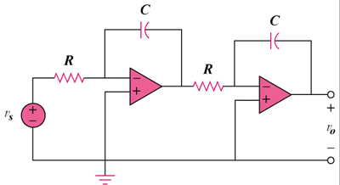

Figure 16.107
For Prob. 16.98.

